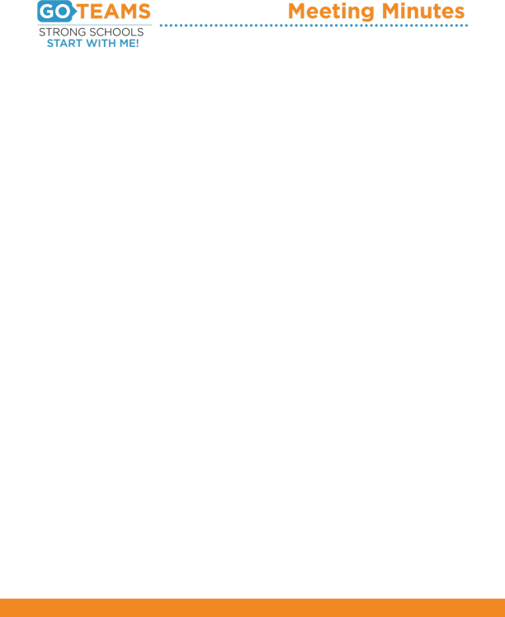

**LONG GO Team Meeting**

**Date: November 14, 2018**

**Time: 6:00 P.M.**

**Location: Principal Conference Room**

1. **Call to Order**
2. **Roll Call; Establish Quorum**
3. **Action Items** 
   1. Approval of Agenda:
   2. Fill Vacant Positions
   3. Fill Open Community Member Seat
   4. Election of Officers: Chair, Vice-Chair, Secretary, Cluster Representative
   5. Set GO Team Meeting Calendar
   6. Review and Approve Public Comment Format
   7. Review, Confirm/Update, and Adopt GO Team Norms
4. **Information Items** 
   1. Principal’s Report
5. **Announcements** 
   1. GO Team Announcements from Members
6. **Public Comment**
7. **Adjournment**